Events conducted by the Club FIRE
(Dept. of ECONOMICS )

1. REPORT OF COLLAGE MAKING COMPETITION
(FIRE CLUB)

FIRE (Forum for innovation and research) club conducted its first event for the year 2022-23 on 3rd August 2022 from 11:30 to 12:30 in Gerosa Hall. It was a collage making competition based on the theme “Economic crisis in Sri Lanka”. The Judge for the event was Dr. Afshan Shireen. The event was conducted under guidance of DR. Alice Esther and Dr Sirisha Kasuba . The event witnessed enthusiastic and ardour participation of students from second and third year. Poster and a google form for registration was circulated and the competition was open for students of all the streams
Rules for the event were as follow:
- Students were asked to participate in a team of 3-5 members
- Participants had to bring their own material and stationery
- A3 sheet was to be used for making the collage
- Judgement criteria: content, creativity and clarity
- Students were asked to give a brief explanation of their collage.
Following are the details about the event: -
1)Number of teams participated = 6
2)Winner – team lanko warriors
- B . Sunitha - BA 2EPP
- V Sai Taruni - BA 2 EPP
- Annapurna Das - BA 2EPSM
3)Runner up – team cornflakes
- Ipshitha Hazra
- Khushi Jain
- Akankshaya Sundrray
- Rizu kumari
All the teams had put their best effort and participated with great zeal. At the end of the competition winners were announced by Dr. Afshan Shireen. All the winners and participants are to be awarded with certificate to recognize their participation in the event.

2. QUIZ COMPETITION REPORT

A quiz competition was organised by Fire club on 17th August 2022 to select the students who can represent St Francis college for women at the cluster level quiz competition which was going to be held to commemorate 75 years of independence ( Azadi ka Amrit Mahotsav) . The competition was held between 11:30 PM to 12:30 PM at the venue UG 201 and 202. The competition was open to students from all the streams and it was held in the presence of Dr.Rooman , Dr K.Sirisha and Dr.Alice. The winners were declared on the same day by 2:52. Following were the winners of the quiz competition
- Anshika Sagar - BA1 EPP
- Umaimah Aizaz - BA1 HLP
- V . Sai Taruni - BA 2 EPP

3. Budget pe Charcha
A group discussion was conducted on 2/2/23 on the budget which was released. The students had a great learning experience and also learnt a lot about the economy and the meaning of various terminologies used in the special edition of economic times on budget .

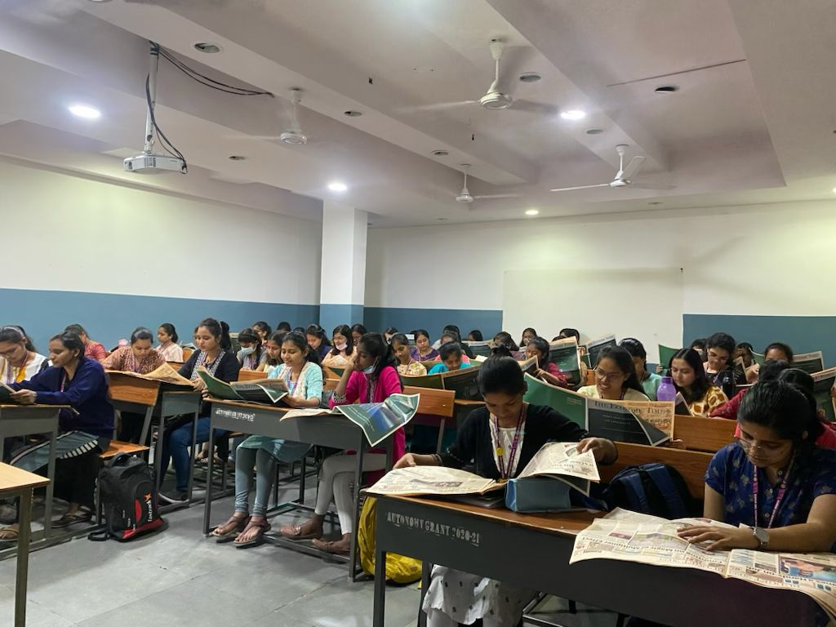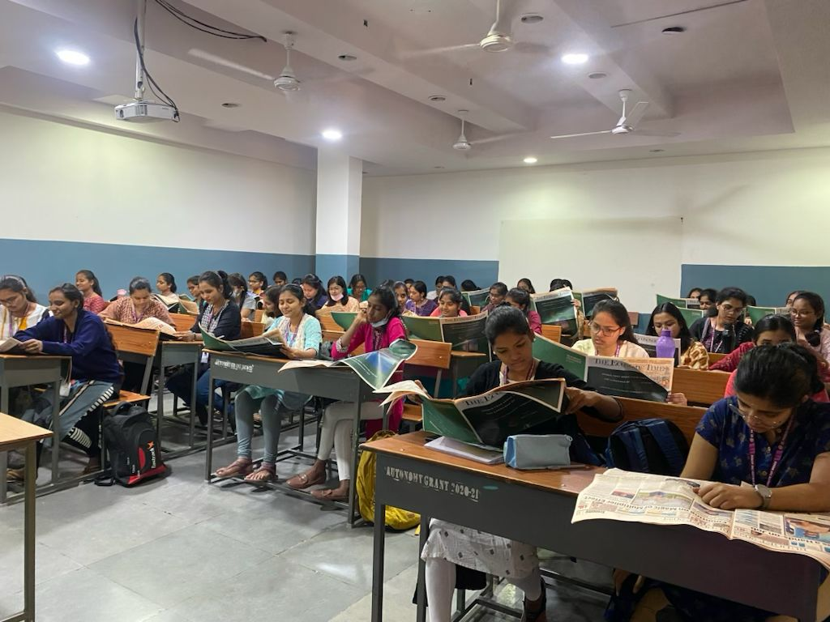

Outreach Report - 2022-23 (Daan Utsav)
Class: BA EPP, EPSm, HPP, HLP 3rd year, HPP 2nd Year, PPP 1st year and MA Mass Com 1st Year
Name of Mentors: Ms. D. Rupali and Dr. Rohit Kumar Pandey
Date: 5th of December, 2022,
Number of Students participated: 80
Organization Visited: Second Chance Foundation, Yapral, Secunderabad
About the Organization: The foundation is a destitute home set up for the old aged.
Activities Done: Students interacted with inmates, played some soothing and energising music, danced alongside them and sang beautiful carols.
Amount Collected: 17000 rupees
Materials Collected: Fruits, Biscuits, Shawls, toiletries
Number of People benefited: 40
Feedback from the organization: The staff members of the organization were very happy that our students were able to spend their time with the inmates. They were also very glad about the contributions received and thanked us for the same.
Students Feedback: We were lucky enough to spend two fulfilling hours with the inmates which was one of the most heart-warming experiences for all present. To be able to see the smiles on their faces filled our hearts with happiness and a sense of bliss! They shared their insightful experiences with us and advised us to live a happy and productive life by loving and respecting our parents and everyone around us. They wholeheartedly showered their blessings upon us. We called it a day and left the foundation in the afternoon.

REPORT AND PHOTOS OF STUDENT ACHIEVEMENTS (REFER SL NO. 8)
Class – Ba 2 EPP
Student- Amrutha
Competition – National level young economist competition
Venue- Christ University Bangalore
Date -17-2-23
